Mukesh Patel School of Technology Management & Engineering
Department of Computer Engineering
NMIMS University
MINI PROJECT REPORT
on
Smart Hospital Emergency & Patient Triage System
Course: Data Structures and Algorithms
Class / Semester: BTI CE / Sem VII Division / Batch: D1
Submitted by
Sr. No. | Name of Student | Roll No. / PRN | Contribution
1 | Yashvi Doshi | C130 | Circular Registration Queue (regQueue, enqueueReg, dequeueReg); intake UI pipeline; single and batch nurse triage (triageSingle, triageAll).
2 | Meet Shah | C141 | Acuity-based priority queue (pqHead, pqInsert, pqPop); Code Red bypass; bed preemption (attemptPreemption); cabin allocation (autoAssignDoctors, assignToDoctor).
3 | Harsh Shah | C142 | Master patient linked list (createPatient, findPatientById, cleanup); wait-round and preemption analytics (showStatistics); terminal UI rendering; memory-safe teardown.

Academic Year: 2026 – 2027

1. Title
Project Title: Smart Hospital Emergency & Patient Triage System: An Acuity-Driven Dual-Queue Simulation with Dynamic Preemption in C
Abstract:
Strict first-in-first-out scheduling in a hospital emergency department delays critical patients behind routine cases, because a Severity-5 arrival must wait for every earlier token to be served. This project implements a hybrid dual-path simulation in C in which routine walk-ins queue in a fixed-capacity circular FIFO intake buffer and are then triaged into an acuity-sorted linked-list priority queue ordered by severity and token number, while Code Red patients bypass intake entirely. Three doctor cabins are held in a struct array and advanced in discrete consultation rounds, and a Code Red arrival that finds every cabin occupied preempts the least severe active consultation in O(M + n) time, with the displaced patient re-queued at its original priority. Every patient is also retained in a tail-appended master linked list that gives O(1) audit appends, per-tier wait analytics and a leak-free teardown; in the bundled 15-patient demonstration the Code Red patient waited 0 rounds, whereas strict FIFO would have made the same patient wait 2 rounds.

2. Problem Formulation

2.1 Problem Statement
Emergency departments (EDs) operate under unpredictable surges in which patients with very different clinical urgency arrive within minutes of each other. Triage nurses classify each patient with the Emergency Severity Index (ESI), a five-level scale in which level 1 is the most urgent [4]. For ease of numerical comparison the program inverts the scale, so that the stored severity is S = 6 − ESI: S = 5 (Critical), 4 (Urgent), 3 (Moderate), 2 (Low) and 1 (Minor), exactly as listed in the sevNames[] array.
A single FIFO queue is clinically unsafe because waiting time is independent of acuity. With M doctors working in discrete rounds, a patient who has k patients ahead waits floor(k / M) rounds whether the patient is Minor or Critical. A Critical ambulance arrival behind six routine cases and served by M = 3 cabins would therefore wait two full rounds. A second source of risk is cabin contention: when all cabins are occupied, a critical arrival cannot be allowed to wait for a lower-acuity consultation to end naturally, so the system needs a rule for pausing a less severe consultation.
The scope of the project is a single-ED, single-threaded, console-driven simulation in which time advances in discrete rounds. Each patient is described only by name, age and severity; no vitals, scheduling calendar or persistent storage are modelled. The functional objectives are:
- Dual-path intake. Routine patients join a bounded circular FIFO queue; Code Red patients skip it.
- Acuity-driven ordering. Waiting patients are served by severity descending and, within a tier, by token number ascending (strictly FIFO inside a tier).
- Immediate bed preemption. When every cabin is busy, a Severity-5 arrival replaces the least severe active consultation, and the displaced patient returns to the priority queue with its original token.
- Controlled starvation risk. No later arrival of the same severity can overtake an earlier one, and the per-tier maximum waiting time is measured so that starvation is visible in the analytics.
- Auditability. Every patient is kept in a permanent master list that supports search by ID and wait-round statistics by severity tier and by doctor.
- Zero dynamic-memory leaks. Every malloc is paired with exactly one free, and all heap memory is released on shutdown.
- Robust input handling. All numeric input is parsed with strtol and range-checked; names are truncated on UTF-8 character boundaries and never overflow the 30-byte field.

2.2 Data
Table 2.1 lists the data the program stores and the data structure chosen to hold each item.
Sr. No. | Data Item | Description
1 | struct Patient  (master node) | Master record and singly-linked node. Fields: id (unique, from nextId), name[30], age, severity (1-5), tokenNumber (unique, monotonic), arrivalRound, treatedRound (-1 until first consultation), waitRounds (-1 until first consultation), doctorId (0 if none), status (1 Awaiting Triage, 2 In Priority Line, 3 In Consultation, 4 Discharged, 5 Preempted/Paused) and next. About 80 bytes per node on a 64-bit platform.
2 | struct PQNode  (priority-queue node) | Lightweight 16-byte list node holding a struct Patient *patient and struct PQNode *next. The priority queue stores pointers, never copies, so a patient exists exactly once in memory. Head pointer: pqHead.
3 | struct Doctor  doctors[MAX_DOCTORS] | Fixed array of three cabin records: id, current (pointer to the patient in the cabin, or NULL when free), totalServed (first consultations started) and preemptCount (times this cabin was seized by a Code Red).
4 | regQueue[QUEUE_SIZE]  front, rear, regCount | Static circular FIFO array of 50 Patient * slots for the registration hall. front and rear advance modulo 50; regCount disambiguates full from empty. Initial state: front = 0, rear = -1, regCount = 0.
5 | Master singly linked list  head, tail | Permanent audit repository of every patient ever registered, appended at tail in O(1). It is the single owner of all Patient memory and is traversed by search, the master log and the statistics.
6 | Statistics arrays  statTreated[6], statWaitSum[6], statWaitMax[6] | Per-severity-tier counters (index 1-5) updated once per patient at first consultation: patients treated, total rounds waited, and maximum rounds waited.
7 | Global counters | nextId, tokenCounter, currentRound (the simulation clock), totalTreated, totalWaitRounds and totalPreemptions.
8 | Constants and labels | MAX_DOCTORS = 3, QUEUE_SIZE = 50, NAME_SIZE = 30, MAX_SEV = 5; sevNames[] maps severity to its label.

2.3 Functions
Table 2.2 lists the operations supported by the program, grouped by subsystem.
Sr. No. | Function Name | Purpose | Input | Output
Intake subsystem: circular registration queue
1 | enqueueReg | Insert a patient at the rear of the intake queue using modulo wraparound. | Patient pointer | 1 on success, 0 if full
2 | dequeueReg | Remove and return the patient at the front of the intake queue. | None | Patient pointer or NULL
3 | isRegFull, isRegEmpty | Capacity tests based on regCount. | None | Boolean (int)
Priority subsystem: acuity-sorted linked list
4 | hasPriority | Dual-criterion comparator: higher severity wins, then lower token number. | Two patient pointers | 1 if first outranks second
5 | pqInsert | Insert a patient at its sorted position. | Patient pointer | 1 on success, 0 if allocation fails
6 | pqPop | Detach and return the highest-priority patient. | None | Patient pointer or NULL
7 | getPQRank, getPQSize | Rank of a given patient and current queue length. | Patient pointer / None | Rank (0 if absent) / size
Master record subsystem: singly linked list
8 | createPatient | Allocate a record, assign ID and token, append at tail. | Name, age, severity | Patient pointer or NULL
9 | findPatientById | Linear search of the master list. | Integer ID | Patient pointer or NULL
10 | cleanup | Free every master node and every priority-queue node. | None | None (heap released)
Allocation and preemption subsystem
11 | assignToDoctor | Place a patient in a cabin; record statistics on first consultation only. | Patient pointer, cabin index | Count of earlier tokens bypassed
12 | autoAssignDoctors | Fill every free cabin from the head of the priority queue. | None | Number of patients assigned
13 | attemptPreemption | Pause the least severe active consultation and admit a critical patient. | Critical patient pointer | 1 if preempted, 0 otherwise
Workflow subsystem
14 | emergencyCodeRedBypass | Register a Severity-5 patient, skip intake, then assign or preempt. | Name, age (keyboard) | None (state change, UI output)
15 | triageSingle | Move the front intake patient into the priority queue (peek, insert, then dequeue). | None | Patient pointer or NULL
16 | triageAll | Batch-triage every patient in the intake queue. | None | None (count reported)
17 | runNextRound | Discharge all cabins, advance the clock, dispatch the next patients. | None | None (state change)
18 | manualDischarge | Free one cabin early. | Doctor number | None
Monitoring, analytics and demonstration
19 | showStatistics | Overview, wait analysis, per-tier waits and doctor workload histograms. | None | Formatted report
20 | showVisualWorkflow | Draw the live dual-path movement diagram and bed occupancy. | None | Formatted diagram
21 | loadDemo | Ingest a scripted 15-patient scenario that includes a preemption. | None | None (state change)

3. Solution Design

3.1 Data Structures Used
The design couples three linked or array-based structures through shared, non-owning pointers. Figure 3.1 shows the end-to-end patient flow. A patient is allocated once by createPatient, appended to the master list, and from then on is referenced (never copied) by the intake array, the priority-queue nodes and the doctor cabins.
Walk-in (Option 1) Code Red (Option 2)
| |
v | (skips the intake queue)
+--------------------------------+ |
| regQueue[50] FIFO | |
| circular array, 50 slots | |
+----------------+---------------+ |
| triageSingle() / triageAll() |
| -> pqInsert() |
v v
+------------------------------------------------------------+
| Priority queue: acuity-sorted singly linked list |
| order key: severity DESC, then tokenNumber ASC |
+------------------------------+-----------------------------+
| pqPop() or, when every cabin is busy,
| attemptPreemption() for a Code Red
v
+------------------------------------------------------------+
| doctors[0..2]: Cabin D1 | Cabin D2 | Cabin D3 |
+------------------------------+-----------------------------+
| runNextRound()
v
Discharged (status 4)

Every Patient is also appended to the Master List (head ... tail) by createPatient().

Figure 3.1: Dual-path patient flow through the intake queue, priority queue and doctor cabins
3.1.1 Structure declarations
The three structures below are taken from dsa_final_code.c (the long comment on status is re-wrapped to fit the page).
struct Patient {
int id;
char name[NAME_SIZE];
int age;
int severity;
int tokenNumber;
int arrivalRound;
int treatedRound;
int waitRounds;
int doctorId;
int status; /* 1=Awaiting Triage, 2=In Priority Line,
3=In Consultation, 4=Discharged, 5=Preempted */
struct Patient *next;
};

struct PQNode {
struct Patient *patient;
struct PQNode *next;
};

struct Doctor {
int id;
struct Patient *current;
int totalServed;
int preemptCount;
};

#define MAX_DOCTORS 3
#define QUEUE_SIZE 50
#define NAME_SIZE 30
#define MAX_SEV 5

struct Patient *head = NULL; struct Patient *tail = NULL; /* master list */
struct Patient *regQueue[QUEUE_SIZE]; /* intake ring */
int front = 0; int rear = -1; int regCount = 0;
struct PQNode *pqHead = NULL; /* priority list */
struct Doctor doctors[MAX_DOCTORS]; /* cabins */

3.1.2 Memory organisation
Figure 3.2 contrasts the three organisations. The circular array reuses a fixed block of 400 bytes (50 pointers of 8 bytes) by wrapping indices modulo 50. The priority queue and the master list are dynamically allocated singly linked lists; the priority queue stores only 16-byte nodes that point into the master list.

(A) regQueue[QUEUE_SIZE=50] - static circular array of Patient pointers
0 1 2 ... 47 48 49
+-------+-------+-------+-------+-------+-------+-------+
| P7 | P8 | . | ... | . | P5 | P6 |
+-------+-------+-------+-------+-------+-------+-------+
^rear ^front
front = 48, rear = 1, regCount = 4 -> service order: P5, P6, P7, P8
enqueue: rear = (rear + 1) % 50 dequeue: front = (front + 1) % 50
full <=> regCount == 50 empty <=> regCount == 0

(B) Acuity-sorted priority queue (singly linked, head only)

pqHead --> [ patient | next ] --> [ patient | next ] --> [ patient | next ] --> NULL
| | |
v v v
T#7 S5 Critical T#3 S3 Moderate* T#2 S2 Low
status 3->(popped) status 5 (paused) status 2
order key: severity DESC, then tokenNumber ASC * resumes ahead of newer S3

(C) Master patient list (singly linked, head and tail, append-only)

head --> [P001|T1|S1] --> [P002|T2|S2] --> ... --> [P015|T15|S4] --> NULL
^
tail tail->next = p; tail = p;

(D) Non-owning references into (C): regQueue[i] pqHead->patient doctors[d].current
Only cleanup() frees Patient nodes, so there is no double free.

Figure 3.2: Memory layout of the circular intake array, the sorted priority list and the master list

3.1.3 Patient state transitions
The status field implements a five-state machine. Table 3.1 gives the transitions and the function that performs each one.
Status | Meaning | Entered by | Left by
1 | Awaiting Triage | createPatient (routine walk-in, queued in regQueue) | triageSingle sets status 2
2 | In Priority Line | triageSingle; or Code Red after pqInsert | assignToDoctor sets status 3
3 | In Consultation | assignToDoctor (first admission, resumption, or preemption winner) | runNextRound / manualDischarge set status 4; attemptPreemption sets status 5
4 | Discharged | runNextRound or manualDischarge | Terminal state
5 | Preempted / Paused | attemptPreemption (victim re-queued in the priority list) | autoAssignDoctors pops it and assignToDoctor sets status 3

The full lifecycle is therefore 1 → 2 → 3 → 4 for an uninterrupted patient and 1 → 2 → 3 → 5 → 3 → 4 for a preempted patient. A Code Red patient is created with status 1 but never visits regQueue; it moves directly to status 2 or, when preemption succeeds, to status 3. Patients in status 5 remain inside the priority queue, so they are counted as "Waiting in Priority Line" by the analytics.

3.2 Algorithms
In the complexity analysis below, n is the current length of the priority queue, N is the number of master records, k is the number of patients in the intake queue, M = 3 is the number of doctors and S = 5 is the number of severity tiers. The simulation clock is written τ and is stored in currentRound.
3.2.1 Circular intake queue (supporting algorithm)
ALGORITHM enqueueReg(p) ALGORITHM dequeueReg()
IF regCount = QUEUE_SIZE IF regCount = 0 THEN RETURN NULL
THEN RETURN 0 p <- regQueue[front]
rear <- (rear + 1) MOD QUEUE_SIZE front <- (front + 1) MOD QUEUE_SIZE
regQueue[rear] <- p regCount <- regCount - 1
regCount <- regCount + 1 RETURN p
RETURN 1

Each operation performs one comparison, one modulo and one array access, so both are worst-case and best-case O(1) with O(1) extra space; no amortisation is required because the buffer never shifts or reallocates. A naive linear array queue would need O(k) shifting per dequeue, and a growable array would give O(1) only in the amortised sense. Because front and rear alone cannot distinguish a full ring from an empty one, the explicit counter regCount is used. Traversal for display (showRegistrationQueue) is O(k) using the index (front + i) MOD 50.
3.2.2 Dual-criterion acuity priority insertion (pqInsert and hasPriority)
FUNCTION hasPriority(a, b)
IF a.severity <> b.severity THEN RETURN a.severity > b.severity
RETURN a.tokenNumber < b.tokenNumber

ALGORITHM pqInsert(p)
node <- allocate PQNode ; IF node = NULL THEN RETURN 0
node.patient <- p
prev <- NULL ; curr <- pqHead
WHILE curr <> NULL AND NOT hasPriority(p, curr.patient) DO
prev <- curr ; curr <- curr.next
node.next <- curr
IF prev = NULL THEN pqHead <- node ELSE prev.next <- node
RETURN 1

ALGORITHM pqPop()
IF pqHead = NULL THEN RETURN NULL
temp <- pqHead ; p <- temp.patient ; pqHead <- pqHead.next
free(temp) ; RETURN p

Step-by-step logic.
- Allocate a 16-byte node. If malloc fails, return 0 so that the caller can leave all state unchanged.
- Walk from the head while the new patient does not outrank the current node. Ranking compares severity first (descending) and token number second (ascending).
- Stop at the first node that the new patient outranks, or at the end of the list.
- Splice the node in with at most two pointer writes: node.next <- curr and either pqHead <- node or prev.next <- node.

Correctness. Token numbers are unique, so hasPriority is a strict total order on (severity descending, token ascending) and no two patients ever tie. The loop maintains the invariant that the list is sorted under this order, so insertion at the first position the new node outranks preserves it. A preempted patient keeps its original token, so it re-enters ahead of every later patient of the same severity.
Complexity.
- Best case O(1): the new patient outranks the head (for example the first Critical patient entering a queue of lower tiers) or the queue is empty.
- Worst case O(n): the new patient has the lowest rank and is appended after n comparisons, each O(1). The average case under uniformly random severities is also Θ(n), so insertion is linear.
- Pointer reassignment cost: the splice itself is O(1), at most two pointer writes, so the search dominates. Over N insertions into a queue that never exceeds q nodes the total cost is O(N q).
- Dequeue: pqPop is O(1) because the highest-priority patient is always the head. Space: O(1) auxiliary per insertion, and O(n) for the queue itself.

3.2.3 Live consultation bed preemption (attemptPreemption)
ALGORITHM attemptPreemption(c) // c = critical arrival (S = 5)
target <- -1 ; lowest <- c.severity
FOR i <- 0 TO M-1 DO // scan the M cabins for min severity
IF doctors[i].current <> NULL AND doctors[i].current.severity < lowest
THEN lowest <- doctors[i].current.severity ; target <- i
IF target = -1 THEN RETURN 0 // nobody less severe than c
v <- doctors[target].current // victim
IF pqInsert(v) = 0 THEN RETURN 0 // re-queue first: failure changes nothing
v.status <- 5 ; v.doctorId <- 0 // arrivalRound, token, treatedRound kept
assignToDoctor(c, target) // c.status <- 3, stats recorded
doctors[target].preemptCount++ ; totalPreemptions++
RETURN 1

Step-by-step logic.
- Scan the M cabins and track the strictly lowest severity that is below the critical patient's. The strict inequality means equal-severity patients are never evicted, which prevents two Code Red patients from displacing each other, and ties between equally low cabins resolve to the lowest cabin index.
- If no such cabin exists, return 0. The caller then places the critical patient in the priority queue at its sorted rank for the very next round.
- Re-insert the victim into the priority queue before changing any other state, so that an allocation failure leaves the system exactly as it was (atomic preemption).
- Mark the victim as Preempted (status 5) and release its cabin link. Its token, arrival round and treatedRound are preserved.
- Admit the critical patient to the freed cabin. assignToDoctor updates statistics only when treatedRound == -1, so a resumed victim is not counted twice.

Complexity. The scan is Θ(M), which is constant for M = 3. If no victim exists the function returns after the scan in O(M) time. A successful preemption adds one pqInsert (O(n)), the bypass count inside assignToDoctor (a full Θ(n) pass over the queue) and the rank report from getPQRank (O(n)), giving Θ(M + n) in total, which is O(n) for fixed M. Auxiliary space is O(1) plus one 16-byte node.

3.2.4 Batch consultation and discrete round execution (runNextRound)
ALGORITHM runNextRound()
FOR i <- 0 TO M-1 DO // flush completed consultations
IF doctors[i].current <> NULL THEN
doctors[i].current.status <- 4 ; doctors[i].current <- NULL
tau <- tau + 1 // currentRound++
autoAssignDoctors()

ALGORITHM autoAssignDoctors()
WHILE pqHead <> NULL DO
d <- getFreeDoctorIndex() ; IF d = -1 THEN BREAK
p <- pqPop() // highest-priority patient
assignToDoctor(p, d)

ALGORITHM assignToDoctor(p, d)
bypassed <- number of queued patients with token < p.token
p.status <- 3 ; p.doctorId <- doctors[d].id ; doctors[d].current <- p
IF p.treatedRound = -1 THEN // first consultation only
p.treatedRound <- tau ; p.waitRounds <- tau - p.arrivalRound
update doctors[d].totalServed and the per-tier statistics
RETURN bypassed

Step-by-step logic. The round first discharges every busy cabin (status 4), then increments the clock τ ← τ + 1, then repeatedly pops the head of the priority queue into the first free cabin until either the queue or the free cabins are exhausted. Waiting time is defined as τ minus the arrival round and is frozen at the first consultation, so preemption does not distort the analytics.
Complexity. The flush is Θ(M). autoAssignDoctors dispatches at most M patients, and each dispatch costs O(1) for pqPop, O(M) for getFreeDoctorIndex and Θ(n) for the bypass count in assignToDoctor. One round therefore costs O(M (M + n)) = O(n) for fixed M, and draining n waiting patients takes ceil(n / M) rounds.

3.2.5 Routing of Code Red and routine patients (supporting algorithms)
ALGORITHM emergencyCodeRedBypass()
p <- createPatient(name, age, 5) // never enters regQueue
IF countFreeDoctors() > 0 THEN
pqInsert(p) ; p.status <- 2 ; autoAssignDoctors()
ELSE IF attemptPreemption(p) = 0 THEN
pqInsert(p) ; p.status <- 2 // all cabins hold S = 5: queue at rank

ALGORITHM triageSingle()
IF regCount = 0 THEN RETURN NULL
p <- regQueue[front] // peek only
IF pqInsert(p) = 0 THEN RETURN NULL // nothing lost if allocation fails
dequeueReg() ; p.status <- 2 ; RETURN p

triageSingle is O(n) because of pqInsert; its peek, insert, dequeue ordering makes the move atomic. triageAll calls it k times, which costs O(k) when every insertion lands at the head and O(k·n0 + k²) in the worst case for an initial queue length n0. emergencyCodeRedBypass costs O(n) on the preemption path and O(n) on the queueing path; routine registration (registerRoutinePatient) is O(1) because it only appends to the master list and the ring.
3.2.6 Complexity summary
Operation | Best case | Worst case | Extra space
enqueueReg / dequeueReg | O(1) | O(1) | O(1)
pqInsert | O(1) | O(n) | O(1)
pqPop | O(1) | O(1) | O(1)
getPQSize | Θ(n) | Θ(n) | O(1)
getPQRank | O(1) | O(n) | O(1)
createPatient (tail append) | O(1) | O(1) | O(1), one 80-byte node
findPatientById | O(1) | O(N) | O(1)
assignToDoctor | Θ(n) | Θ(n) | O(1)
autoAssignDoctors | O(M) | O(M (M + n)) | O(1)
attemptPreemption | O(M) if no victim | Θ(M + n) on success | O(1)
triageSingle | O(1) | O(n) | O(1)
triageAll | O(k) | O(k·n0 + k²) | O(1)
runNextRound | Θ(M) + dispatch | O(n) | O(1)
showStatistics | Θ(N + M + S) | Θ(N + M + S) | O(1)
cleanup | Θ(N + n) | Θ(N + n) | O(1)

Total static storage is O(1): the intake array (400 bytes), the doctor array and the global counters. Dynamic storage is Θ(N) for the master list plus Θ(n) for the priority nodes, and n ≤ N always because each queued patient also exists in the master list.

4. Justification
Each structure was chosen for the access pattern of its role. Table 5.1 compares the chosen structures with the main alternatives. Complexities follow [2], [3] and [6].
Role | Chosen structure | Alternative | Insert | Remove / access | Decisive factors
Intake buffer | Circular array (fixed, 50) | Singly linked queue | O(1) vs O(1) | O(1) vs O(1) | Same asymptotics. The array has contiguous storage with good cache locality, no per-patient malloc, and a hard bound that models a finite registration hall (isRegFull gives back-pressure).
 |  | Linear array with shifting | O(1) vs O(1) | O(1) vs O(k) | Shifting on every dequeue is avoided by modulo wraparound.
Priority queue | Acuity-sorted linked list | Binary max-heap (array) | O(n) vs O(log n) | O(1) vs O(log n) | A heap has no stable order, so a composite key is still needed; ordered rank display, getPQRank and "next three in line" need O(n log n) or a copy; for N < 100 the constant factors and simplicity dominate.
 |  | Unsorted array / list | O(n) vs O(1) | O(1) vs O(n) | Every dispatch would need a full scan, and ordered display would need a sort.
Master record | Tail-appended singly linked list | Dynamic array (realloc) | O(1) vs amortised O(1), worst O(N) | O(N) vs O(1) by index | Records are referenced by raw pointers from three other structures; realloc can move the block and invalidate them all. A linked list never relocates a node and has no reallocation stall.

Intake buffer
A circular array and a linked queue both give O(1) enqueue and dequeue, so the decision rests on memory behaviour. Registration is a physical hall with finite seats; a fixed array of 50 slots models that bound honestly and turns overflow into an explicit "buffer full" message instead of unbounded heap growth. The ring avoids a malloc/free pair for every walk-in and keeps pointers contiguous, which is cache-friendly. The only subtlety, the full/empty ambiguity of a ring, is resolved by regCount.
Priority queue
A binary heap is asymptotically better for insertion (O(log n) against O(n)), and it would be the right choice for a queue of thousands. Here the queue holds tens of patients at most (n < 100), so the difference is a few dozen pointer comparisons, far below human-visible latency. The sorted list offers advantages that matter more to this project: (i) pqPop is O(1) and the head is always the next patient; (ii) the list is already in service order, so showPriorityQueue, getPQRank and the movement diagram traverse it directly, whereas a heap would need an O(n log n) sort or copy for each display; (iii) ties are broken deterministically by token number without extra bookkeeping, which gives the required FIFO behaviour inside each severity tier; and (iv) re-inserting a preempted patient is the same code path as a first insertion. An unsorted structure was rejected because every dispatch and every display would cost a full scan or sort.
Master record
A dynamic array indexed by ID would make search O(1), but it would reallocate as patients arrive. Because regQueue, pqHead nodes and doctors[].current all hold raw Patient * pointers, any realloc that moves the block would leave them dangling. The tail-pointer linked list guarantees O(1) append with stable addresses, and the O(N) search is acceptable because it is used only for interactive lookup. It also gives a clear single-ownership model, in which cleanup frees each Patient exactly once.
Quantitative illustration
In the bundled demonstration, Token #7 (Sara Khan, Severity 5) arrives while Tokens #4, #3 and #5 occupy the three cabins and Tokens #1, #2 and #6 are waiting. Under strict FIFO with M = 3 the order of service would be tokens 1-3 in Round 1, tokens 4-6 in Round 2 and token 7 in Round 3, so Token #7 would wait floor(6 / 3) = 2 rounds. The implemented system admits Token #7 in Round 1 by preempting the Moderate patient, so its measured wait is 0 rounds (see Section 6).

5. Conclusion
Outcomes achieved
The program meets every objective in Section 2.1. It compiles without warnings under gcc -Wall -Wextra -std=c99 and ran cleanly under AddressSanitizer, UndefinedBehaviorSanitizer and LeakSanitizer, including the demo scenario, a Code Red registration, a round advance and the statistics screen, followed by orderly shutdown. The 15-patient demonstration (Option 15) produced the following measured behaviour after two rounds:
- One preemption: Token #7 (Severity 5) seized Doctor 2 from Token #3 (Moderate), which returned to Rank 1 of the priority line and resumed in Round 2 with 0 rounds waited, counted once.
- Acuity ordering: in the first dispatch Token #4 (Urgent) and Tokens #3 and #5 (Moderate) overtook the earlier Tokens #1 and #2 of lower severity; Token #1 (Minor) was still queued after two rounds.
- Per-tier waits: Critical 0.00, Urgent 0.00 and Moderate 0.00 rounds; Low 1.00 round (maximum 1); overall average 0.33 rounds across the six patients treated.
- State at the end of the demo: 15 tokens, 3 in consultation, 3 discharged, 9 in the priority line and 0 awaiting triage.

Engineering trade-offs
The simulation advances in discrete rounds rather than with continuous real-time multi-threading. Rounds make the behaviour deterministic, reproducible and easy to test, and they avoid locks and data races on the shared queues, but they cannot model partial consultation progress, so a preempted patient restarts a full consultation when resumed. The sorted linked list trades O(n) insertion for O(1) removal and cheap ordered traversal; the fixed intake ring trades flexibility for bounded memory and cache locality; and the master list trades O(N) search for pointer stability and O(1) append.
Edge cases and limitations
- Linear insertion cost. pqInsert is O(n), which would become a bottleneck under extreme queue loads.
- No aging. Ordering is strictly by acuity then token, so under sustained arrivals of higher severities a Minor patient can wait indefinitely; the per-tier maximum wait exposes this but does not correct it.
- Repeated preemption. A patient can be preempted more than once, and a preempted patient does not retain consultation progress.
- Volatile storage. There is no file-backed persistence, so all records are lost on exit.
- Fixed limits. MAX_DOCTORS, QUEUE_SIZE (50 registrations at a time) and the 29-character name are compile-time constants, and manualDischarge frees a cabin without refilling it until the next dispatch.
- Handled edge cases. Full intake buffer, empty queues, invalid numeric input, end-of-input, allocation failure in pqInsert (atomic triage and preemption), a Code Red when every cabin already holds a Severity-5 patient (queued at its rank), and long or multi-byte names.

Future enhancements
- Replace the sorted list with a heap once queues grow large; a Fibonacci heap would also give O(1) amortised decrease-key, which suits an aging rule that raises the priority of long-waiting patients.
- Persist records with an embedded database such as SQLite so that history survives restarts.
- Stream patient vitals as telemetry so severity can be re-scored automatically and trigger re-triage.
- Model consultation durations and partial progress, and add configurable doctor and bed counts.

Working on the project reinforced pointer-based design (sorted insertion, tail append, safe teardown), the value of choosing a structure by its access pattern rather than only its asymptotic bound, and the discipline of making multi-step state changes atomic.

6. Screenshots

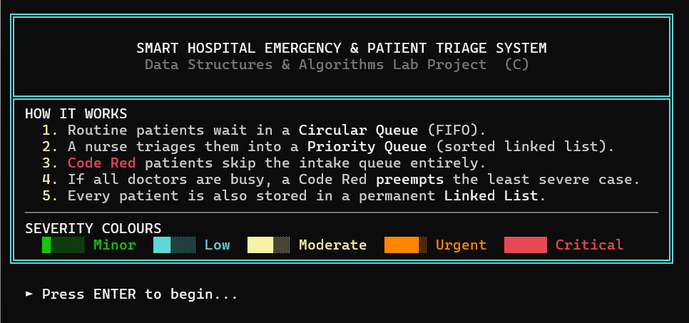
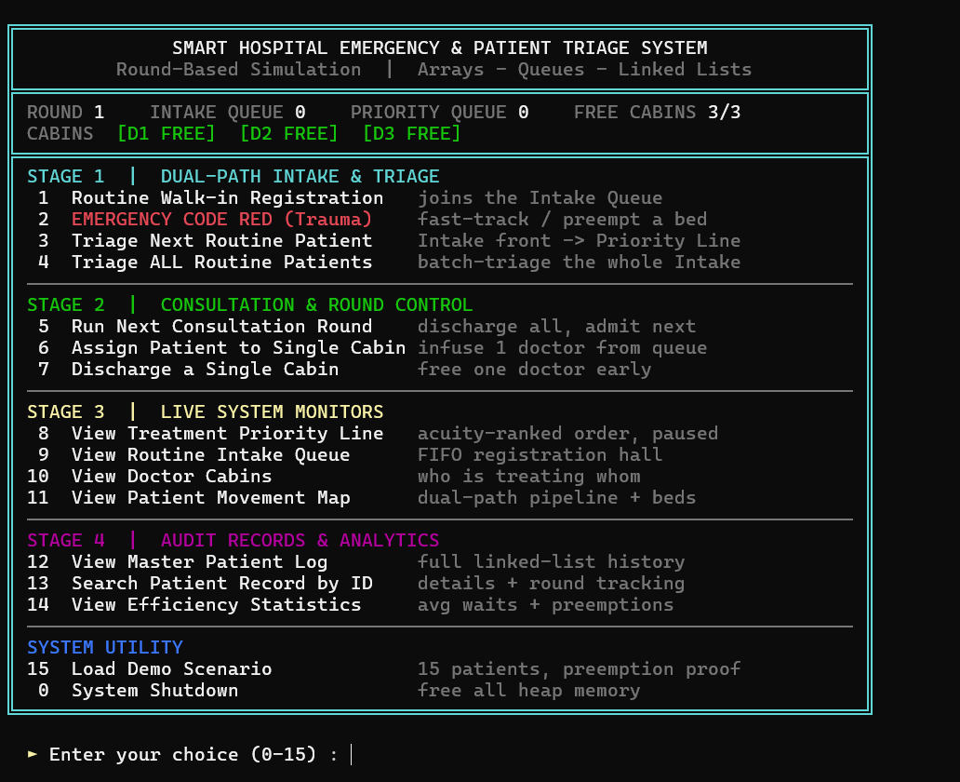
Figure 6.1: Interactive ANSI Terminal Splash and Navigation Dashboard
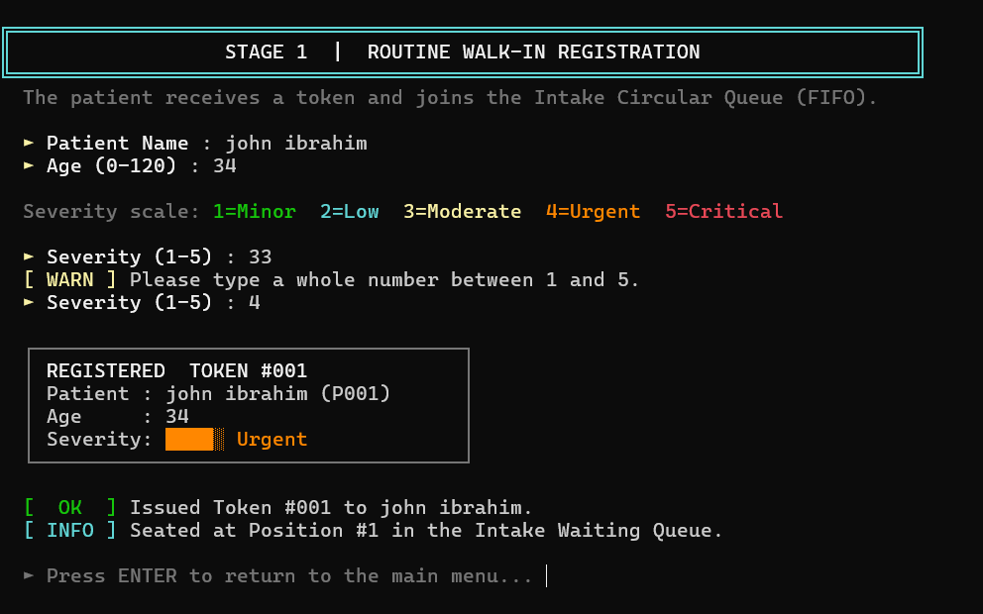
Figure 6.2: Stage 1 Routine Walk-In Registration and Token Issuance Receipt
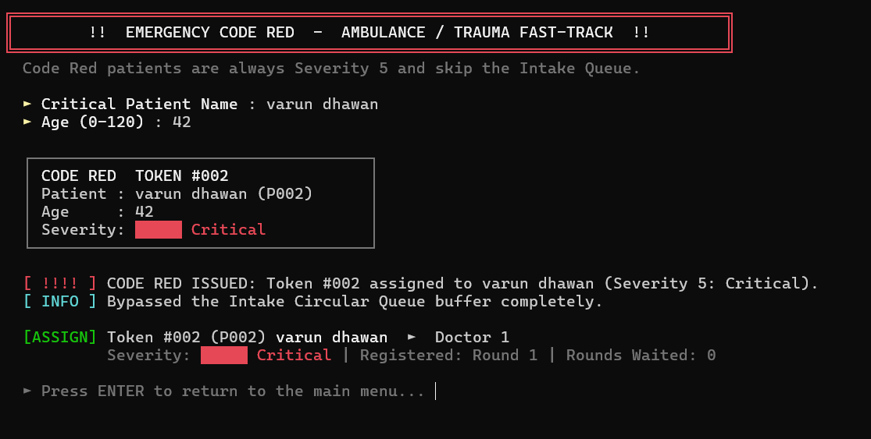
Figure 6.3: Code Red Ambulance Fast-Track and Acuity Preemption Alert
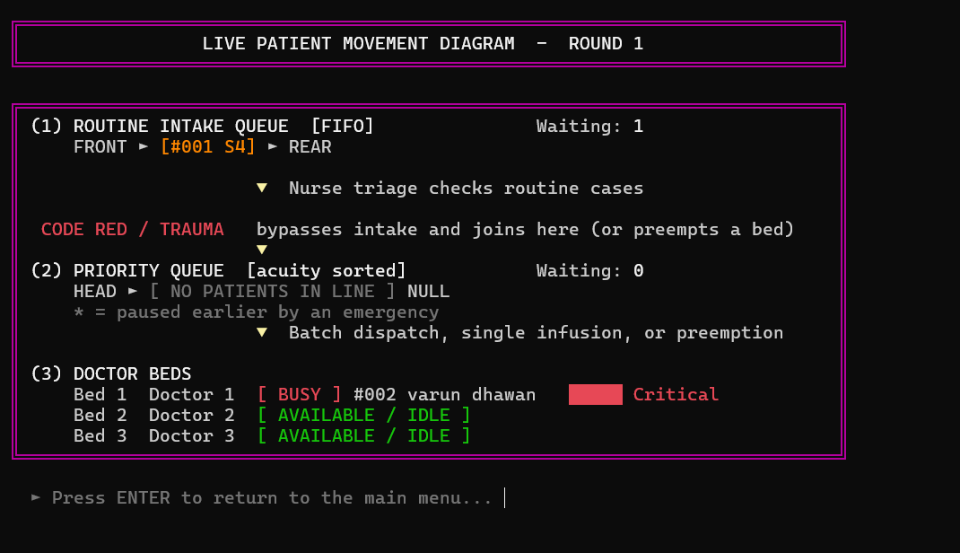 [INSERT SCREENSHOT: Stage 3 Multi-Bed Visual Movement Pipeline & Queue Monitors]
Capture: Option 11 (Patient Movement Map) after the demo; optionally Options 8 and 10 as well.
Figure 6.4: Stage 3 Live Patient Movement Pipeline with Doctor Bed Occupancy
[INSERT SCREENSHOT: Stage 4 Cumulative Wait-Round Analytics & Doctor Workload 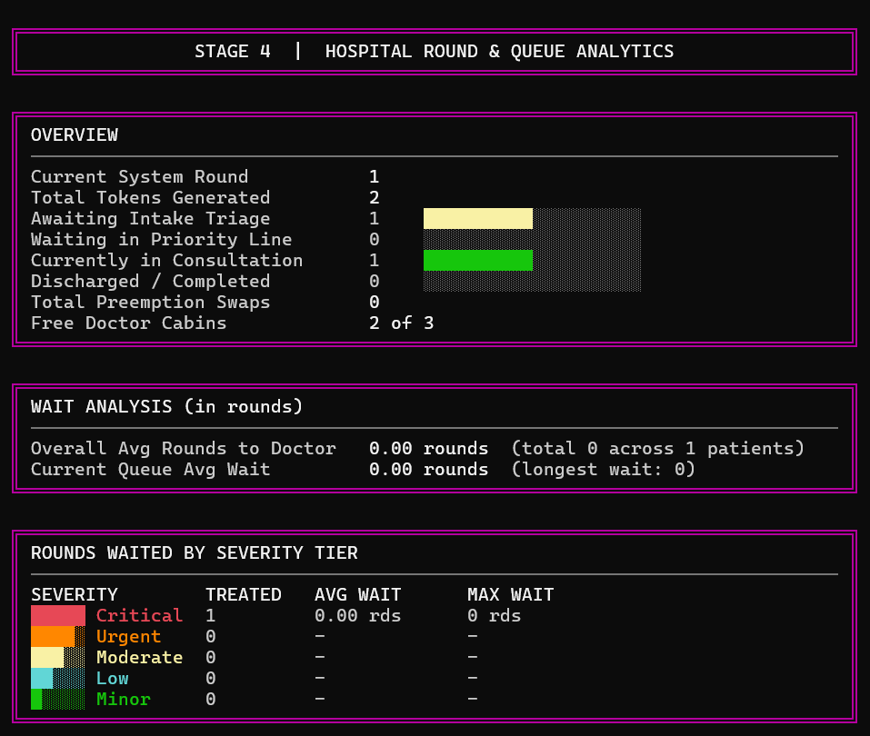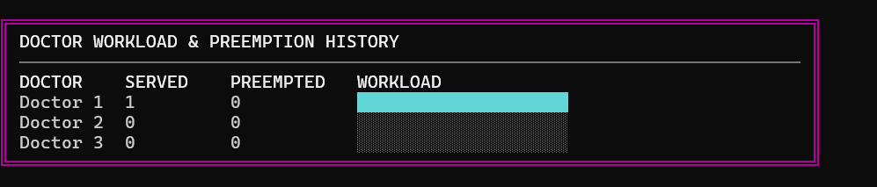

Figure 6.5: Stage 4 Cumulative Wait-Round Analytics and Doctor Workload Histograms

7. Code
GitHub Repository Link:
https://github.com/Meetshah121/dsa_termend_project

Detail | Description
Programming Language | C (C99 / C11), procedural, single source file.
Compiler / IDE Used | GCC 13.3 on Linux (also supported: Clang and MSVC). Any text editor or IDE.
Main Source File(s) | dsa_final_code.c (1,625 lines).
Build Command | gcc -Wall -Wextra -std=c99 -o triage dsa_final_code.c
How to Run | ./triage (Windows: triage.exe). Optional flags: --ascii, --nocolor, --color. On a fresh start choose Option 15 to load the 15-patient demonstration, then Options 11, 12 and 14 to inspect the pipeline, master log and analytics.
Platforms | Linux, macOS and Windows 10+ (virtual-terminal processing is enabled automatically; UTF-8 box drawing falls back to ASCII).

Key Code Snippets:
int hasPriority(struct Patient *a, struct Patient *b) {
if (a->severity != b->severity)
return a->severity > b->severity;
return a->tokenNumber < b->tokenNumber;
}

int pqInsert(struct Patient *p) {
struct PQNode *node = (struct PQNode *)malloc(sizeof(struct PQNode));
struct PQNode *curr, *prev = NULL;

if (!node) {
uiErr("Heap allocation failed while queuing a patient.");
return 0;
}
node->patient = p;
node->next = NULL;

curr = pqHead;
while (curr != NULL && !hasPriority(node->patient, curr->patient)) {
prev = curr;
curr = curr->next;
}

if (prev == NULL) {
node->next = pqHead;
pqHead = node;
} else {
node->next = curr;
prev->next = node;
}
return 1;
}

Listing 7.1: Dual-criterion priority insertion with deterministic tie-breaking
int attemptPreemption(struct Patient *criticalPatient) {
int i;
int targetDoc = -1;
int lowestSev = criticalPatient->severity;
struct Patient *preemptedPatient;
char b1[160], b2[160], title[160], n1[96], n2[96];

for (i = 0; i < MAX_DOCTORS; i++) {
if (doctors[i].current != NULL) {
if (doctors[i].current->severity < lowestSev) {
lowestSev = doctors[i].current->severity;
targetDoc = i;
}
}
}

if (targetDoc == -1) {
return 0;
}

preemptedPatient = doctors[targetDoc].current;

/* Re-queue the paused patient FIRST; if that fails, change nothing. */
if (!pqInsert(preemptedPatient)) return 0;

fitName(n1, sizeof n1, preemptedPatient->name, 22, 1);
fitName(n2, sizeof n2, criticalPatient->name, 22, 1);
sevBadge(b1, sizeof b1, preemptedPatient->severity);
sevBadge(b2, sizeof b2, criticalPatient->severity);
snprintf(title, sizeof title, "!! ACUITY PREEMPTION TRIGGERED ON DOCTOR %d !!", doctors[targetDoc].id);

printf("\n");
boxTop(cRED);
boxCenter(title, cBLD);
boxMid();
row("%sPAUSED %s Token #%03d %s %s",
cYEL, cRST, preemptedPatient->tokenNumber, n1, b1);
row("%sEMERGENCY%s Token #%03d %s %s",
cRED, cRST, criticalPatient->tokenNumber, n2, b2);
boxBot();

preemptedPatient->status = 5;
preemptedPatient->doctorId = 0;
uiWarn("Token #%03d (%s) paused and returned to Priority Line at Rank #%d.",
preemptedPatient->tokenNumber, preemptedPatient->name, getPQRank(preemptedPatient));

assignToDoctor(criticalPatient, targetDoc);
doctors[targetDoc].preemptCount++;
totalPreemptions++;

uiOk("Emergency Token #%03d (%s) immediately admitted to Doctor %d bed!",
criticalPatient->tokenNumber, criticalPatient->name, doctors[targetDoc].id);

return 1;
}

Listing 7.2: Bed preemption with atomic re-queue of the displaced patient
struct Patient *createPatient(const char *name, int age, int severity) {
struct Patient *p = (struct Patient *)malloc(sizeof(struct Patient));
if (!p) {
uiErr("Heap allocation failed.");
return NULL;
}
p->id = nextId++;
fitName(p->name, NAME_SIZE, name, NAME_SIZE - 1, 0);
p->age = age;
p->severity = severity;
p->tokenNumber = ++tokenCounter;
p->arrivalRound = currentRound;
p->treatedRound = -1;
p->waitRounds = -1;
p->doctorId = 0;
p->status = 1;
p->next = NULL;

if (head == NULL) {
head = tail = p;
} else {
tail->next = p;
tail = p;
}
return p;
}

void cleanup(void) {
struct Patient *pCurr = head, *pNext;
struct PQNode *qCurr = pqHead, *qNext;

while (pCurr != NULL) {
pNext = pCurr->next;
free(pCurr);
pCurr = pNext;
}
while (qCurr != NULL) {
qNext = qCurr->next;
free(qCurr);
qCurr = qNext;
}
head = tail = NULL;
pqHead = NULL;
}

Listing 7.3: Master-list tail append and complete heap teardown
The complete code is kept in the GitHub repository; only the three routines above are reproduced here because they carry the core algorithms.

References
[1] E. Horowitz, S. Sahni, and S. Anderson-Freed, Fundamentals of Data Structures in C, 2nd ed. Summit, NJ, USA: Silicon Press, 2008.
[2] T. H. Cormen, C. E. Leiserson, R. L. Rivest, and C. Stein, Introduction to Algorithms, 4th ed. Cambridge, MA, USA: MIT Press, 2022.
[3] R. Thareja, Data Structures Using C, 2nd ed. New Delhi, India: Oxford University Press, 2014.
[4] N. Gilboy, P. Tanabe, D. Travers, and A. M. Rosenau, Emergency Severity Index (ESI): A Triage Tool for Emergency Department Care, Version 4, Implementation Handbook, 2012 Edition. Rockville, MD, USA: Agency for Healthcare Research and Quality, AHRQ Pub. No. 12-0014, 2011.
[5] M. A. Weiss, Data Structures and Algorithm Analysis in C, 2nd ed. Reading, MA, USA: Addison-Wesley, 1997.
[6] International Organization for Standardization, ISO/IEC 9899:1999, Programming Languages - C. Geneva, Switzerland: ISO, 1999.

